
expressionism
OLLI Sketchy Abstractions Class 6

Ernst Ludwig Kirchner, Czardas Dancers, oil on canvas, 1908/1920
Public domain

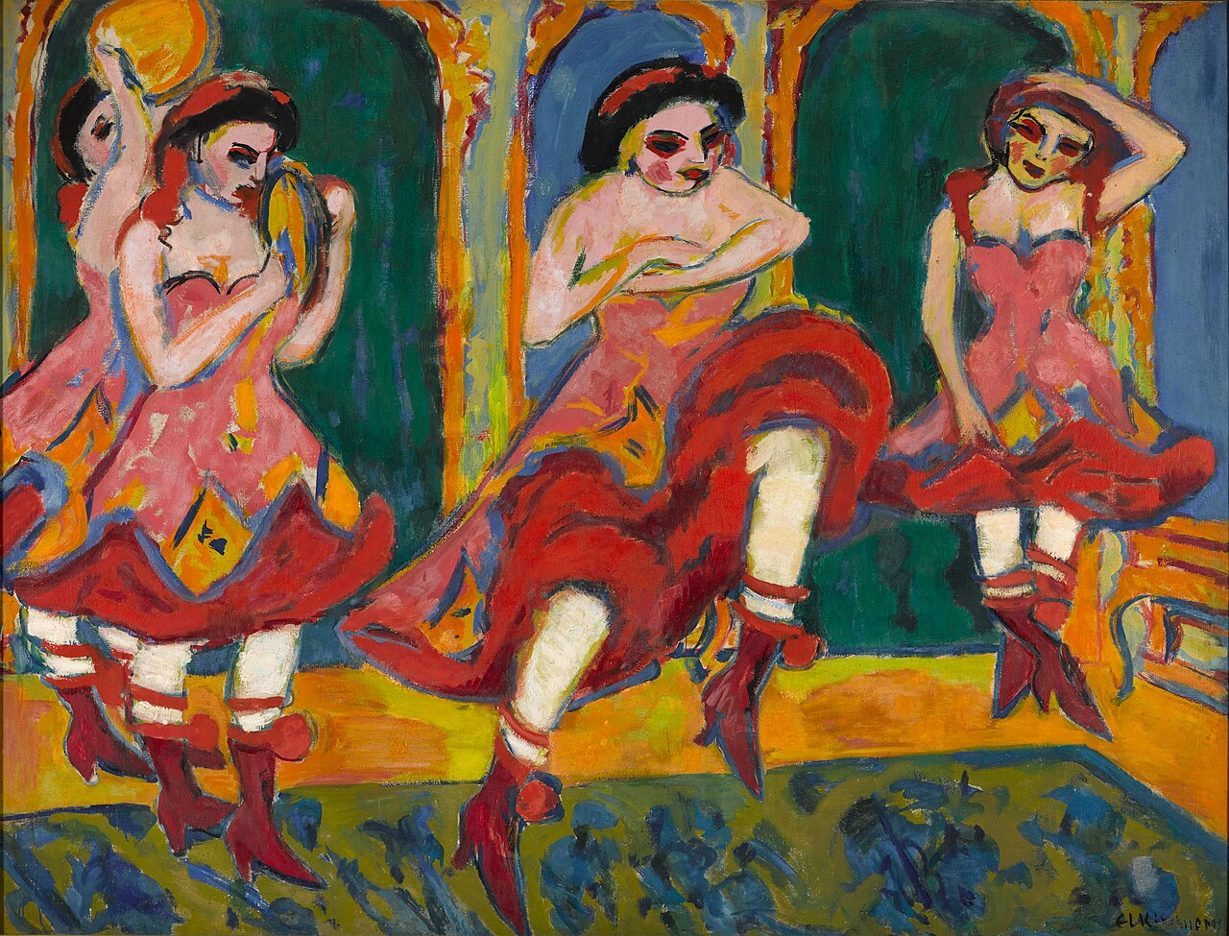

OLLI Sketchy Abstractions Class 6 – Expressionism
Moderator: Harold Dreibelbis

Sketchy describes a rapidly executed freehand drawing that is not usually intended as a finished work.

Abstraction describes art that is unconcerned with the literal depiction of things from the visible world—it can, however, refer to an object or image which has been distilled from the real world.

Expressionism: (per Wikipedia)
Expressionism is a modernist movement, initially in poetry and painting, originating in Northern Europe around the beginning of the 20th century. Its typical trait is to present the world solely from a subjective perspective, distorting it radically for emotional effect in order to evoke moods or ideas.^{[1][2]} Expressionist artists have sought to express the meaning^{[3]} of emotional experience rather than physical reality.^{[3][4]}

Follow this link for information on Expressionism: 1900s Expressionism Gallery
See the entire “Academy to Abstract a timeline” on my website, www.CW4SP | Art.

Core Characteristics of Expressionism (per MS Copilot)
Expressionism’s core characteristics center on subjective emotion, distortion, and intensity—a deliberate break from realism to reveal inner psychological truth.
Below is a structured, detailed breakdown that captures the movement’s essential visual logic.

🎨 Core Characteristics of Expressionism

1. Subjective emotional expression
Expressionist artists prioritized feelings over objective reality, depicting fear, anxiety, ecstasy, spirituality, or psychological tension. The artwork becomes a projection of the artist’s internal state rather than a mirror of the external world.

2. Distortion and exaggeration
To intensify emotional impact, Expressionists used:
- Distorted or elongated forms
- Exaggerated gestures
- Warped perspectives
- Grotesque or primal imagery
These distortions were intentional tools to convey mood rather than mistakes or stylistic quirks.

3. Vivid, non-naturalistic color
Color is liberated from realism. Expressionists often used:
- Harsh, jarring contrasts
- Acidic or symbolic hues
- Saturated, unnatural palettes
Color becomes a psychological force rather than a descriptive one.

4. Aggressive, dynamic brushwork
Paint handling is typically:
- Free
- Energetic
- Thickly applied
- Textured
This physicality reinforces the sense of urgency and emotional intensity.

5. Themes of spirituality, alienation, and modern anxiety
Expressionism often explores:
- Spiritual longing
- Existential dread
- Urban isolation
- Emotional or moral crisis
These themes reflect the movement’s emergence during periods of social upheaval and rapid modernization.

6. Rejection of academic realism
Expressionists opposed the polished, controlled techniques taught in European academies. They sought rawness, immediacy, and authenticity, often collapsing boundaries between painting, music, performance, and other creative forms.

7. Influence of earlier expressive artists
Expressionism draws heavily from:
- Van Gogh (intense color, emotional turbulence)
- Edvard Munch (psychological symbolism)
- James Ensor (grotesque imagery)
These predecessors laid the groundwork for the movement’s emotional and stylistic vocabulary.

🧩 In summary
Expressionism is defined by emotion over realism, distortion over accuracy, and intensity over restraint. It is a movement where the artist’s inner world becomes the true subject—rendered through vivid color, dynamic brushwork, and dramatic, often unsettling imagery.

All links

Britannica
Expressionism | Definition, Characteristics, Artists, Music, Theater, Film, & Facts | Britannica
https://www.britannica.com/art/Expressionism

Tate
Expressionism | Tate
https://www.tate.org.uk/art/art-terms/expressionism

Suggested project – Expressionistic Faces
Look at these mask-like faces:
Schiele - Self Portrait 1915 Kirchner - Doris with Ruff Kirchner - Marzella

What emotions do these images evoke?

Try This: Draw a face (or faces) in a mask-like Expressionistic style.
Remember, we are doing sketches and are heading for abstractions. Do you see how Expressionism leads us down that path? If you create an object d’art, great! But the main thing is to warm up to the artistic freedom these different isms cuddled up with. Be the artist!
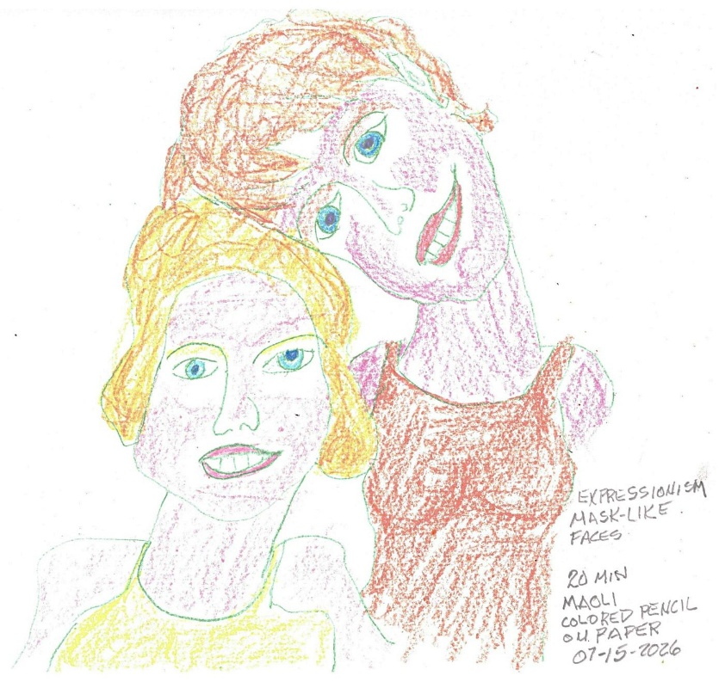
15-minute MAOLI self-portrait. Crayon, colored pencil & markers on paper. 07/11/2026

Suggested project – Expressionistic landscape

Look at these 3 Expressionistic landscapes:
Soutine - Vue de,
Soutine - Chemin de la Fontaine des Tins at Céret
Soutine - Steeple of Saint-Pierre at Céret

What characteristics of Expressionism are evident in these landscapes?

Try This: Draw a landscape in the Expressionistic style.
