
cubism
OLLI Sketchy Abstractions Class 7

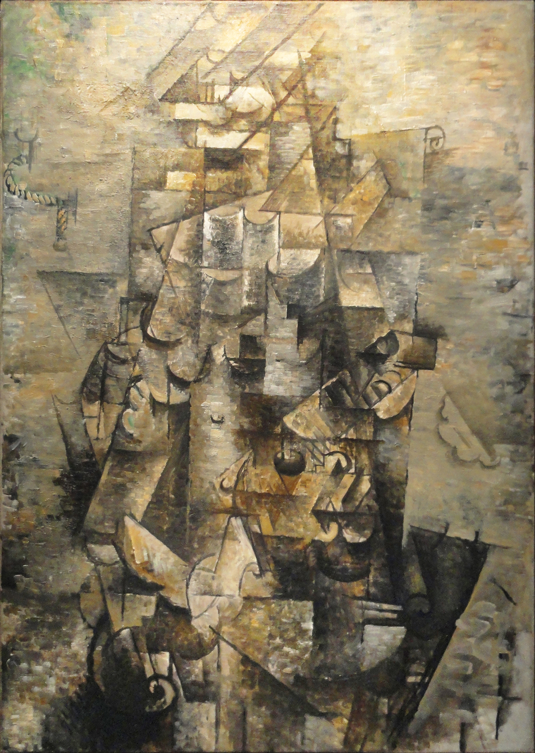
Georges Braque, 1911-12, Man with a Guitar
Public domain in the usa

OLLI Sketchy Abstractions Class 7 – Cubism
Moderator: Harold Dreibelbis

Sketchy describes a rapidly executed freehand drawing that is not usually intended as a finished work.

Abstraction describes art that is unconcerned with the literal depiction of things from the visible world—it can, however, refer to an object or image which has been distilled from the real world.

Cubism: (per Wikipedia)
Cubism is an early-20th-century avant-garde art movement which began in Paris. It revolutionized painting and the visual arts, and sparked artistic innovations in music, ballet, literature, and architecture.
Cubist subjects are analyzed, broken up, and reassembled in an abstract form. Instead of depicting objects from a single perspective, the artist depicts the subject from multiple perspectives to represent the subject in a greater context.^{[1]}

Follow this link for information on Cubism: 1900s Cubism Gallery
See the entire “Academy to Abstract - a timeline” on my website, www.CW4SP | Art.

Core Characteristics of Cubism (per MS Copilot)
Cubism’s core characteristics center on a radical rethinking of how reality can be represented: objects are broken apart, analyzed, and reassembled to show multiple viewpoints at once. At its heart, Cubism rejects traditional perspective and instead treats the canvas as a flat, two-dimensional plane where form is reconstructed through geometry, fragmentation, and simultaneity.

🎯 Core Characteristics of Cubism

1. Multiple viewpoints shown simultaneously
Cubist artists depict subjects from several angles at the same time, breaking away from the single fixed viewpoint that dominated Western art since the Renaissance. This creates a sense of simultaneity and a fuller, more conceptual representation of objects.

2. Fragmentation into geometric planes
Objects and figures are broken into facets, cubes, and angular planes, then reassembled in abstract form. This faceting is one of Cubism’s most recognizable visual signatures.

3. Emphasis on the flatness of the canvas
Cubism deliberately rejects illusionistic depth. Instead of creating a window into space, artists emphasize the two-dimensional surface, flattening forms and compressing space.

4. Rejection of traditional perspective and modeling
Techniques like linear perspective, foreshortening, and chiaroscuro are abandoned. Cubists replace them with color-based perspective, overlapping planes, and structural geometry.

5. Analytical vs. Synthetic phases
Cubism evolved in two major phases:
- Analytical Cubism (1908–1912) — muted colors, dense interwoven planes, highly fragmented forms.
- Synthetic Cubism (1912–1914) — simpler shapes, brighter colors, and the introduction of collage using real materials like newspaper and patterned paper.

6. Influence of Cézanne and African art
Cubism draws heavily from Paul Cézanne’s exploration of form and shifting viewpoints, and from African masks, which inspired stylized, non-naturalistic facial structures.

7. Conceptual rather than perceptual representation
Cubism aims to depict the idea of an object—its structure, its multiple viewpoints, its presence in time—rather than its appearance from a single moment or angle.

🧩 In summary
Cubism is defined by fragmentation, multiple perspectives, geometric abstraction, and a rejection of traditional depth, creating a new visual language that reshaped modern art. It is one of the most influential movements of the 20th century, laying the groundwork for abstraction, Constructivism, Futurism, and more.

All links

Britannica
Cubism | History, Artists, Characteristics, & Facts | Britannica
https://www.britannica.com/art/Cubism

Wikipedia
Cubism - Wikipedia
https://en.wikipedia.org/wiki/Cubism

Tate
Cubism | Tate
https://www.tate.org.uk/art/art-terms/c/cubism

Suggested project – Cubist Face
Look at the faces in these cubist paintings:

Diego Rievra - Portrait of Ramon Gomez de la Serna Picasso - Arlequin au violon

Albert Gleizes - Woman with Black Glove

Can you identify the hair, eyes, nose, mouth and ears of each face?

Try This: Draw a face (or faces) in a Cubist style.
Remember, we are doing sketches and are heading for abstractions. Do you see how Cubism leads us down that path? If you create an object d’art, great! But the main thing is to warm up to the artistic freedom these different isms cuddled up with. Be the artist!
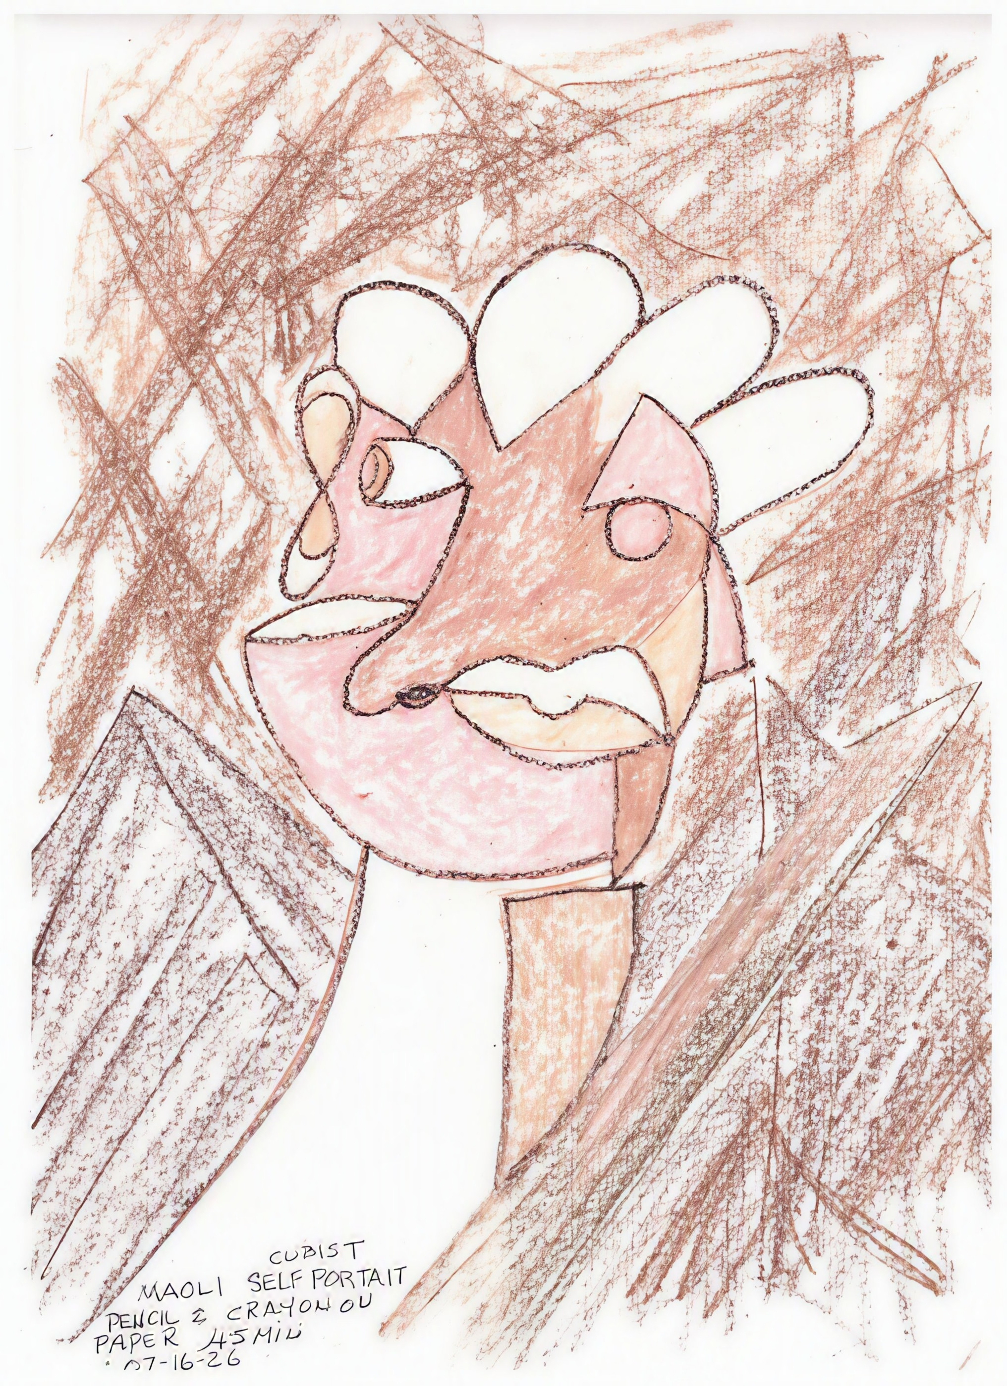

Suggested project – Cubist still-life

Look at these 3 Cubist still-lives:
Georges Braque, Violin and Candlestick
Georges Braque. The Guitar
Juan Gris - Still Life with Checked Tablecloth,
What objects do you find in each still-life?

Try This: Draw a still-life object in the Cubist style.

