
The French Academy
OLLI Sketchy Abstractions Class 1

• Public Domain • Edouard Dantan Un Coin du Salon en 1880.jpg
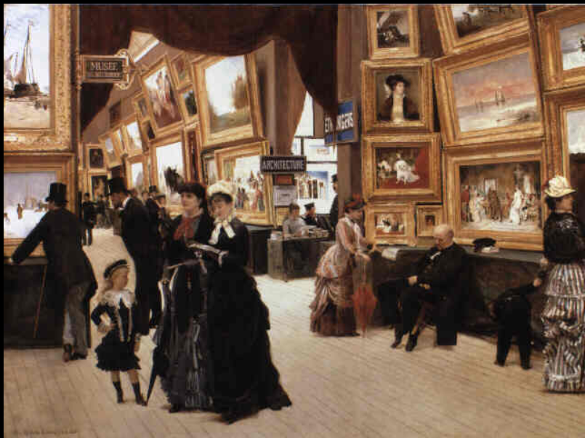

OLLI Sketchy Abstractions Class 1 - The French Academy
Moderator: Harold Dreibelbis

Class Overview:

Sketchy describes a rapidly executed freehand drawing that is not usually intended as a finished work.

Abstraction describes art that is unconcerned with the literal depiction of things from the visible world—it can, however, refer to an object or image which has been distilled from the real world.

Art History - At the beginning of each class, we will look at a little bit of art history to help you understand how art evolved from academic styles to abstractions. This is intended to give you some understanding of the early abstractionist and perhaps inspire your own sketches.

Creativity:
You are a creative person – this is the central concept that drives this class. You may deny your creativity, but it is there. Furthermore, an artist dwells within you. You may not have exercised your artistic potential, but it is there.

You are probably not be able to draw like Albrecht Dürer. I can’t. If you can, you have great talent. But even if you can’t draw like Durer, I bet you can scribble. And in that scribble lies the seed of your creative art.

The French Academy Art Salons Gallery:
Follow this link for information on the classical art styles against which artists of the late 19th and early 20th centuries rebelled. We will discuss this for about 15 minutes in class.

1748 - 1890 The French Academy Art Salons (per Wikipedia)
See the entire “Academy to Abstract a timeline” on my website, www.CW4SP | Art.

Suggested projects – Know your Materials & how to use them:
We will work on learning how to use our materials. Suggested projects are creating your color charts and finding/practicing your natural drawing motions.

Materials:
Bring your materials to class. Here are the materials I recommend: 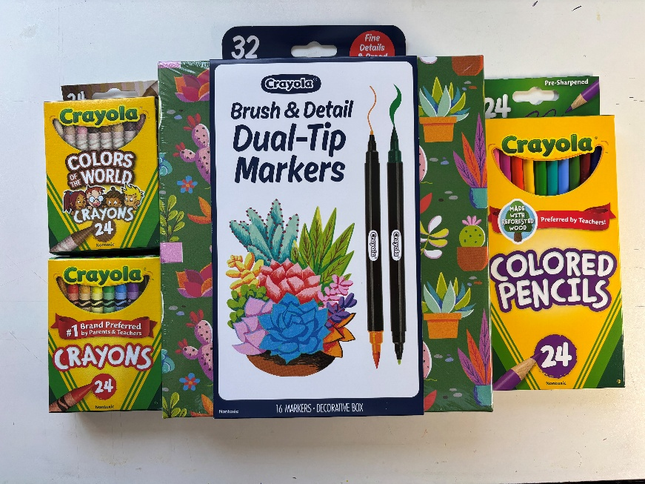
I bought these at Target. They or their equivalent should be available at other similar stores and art and craft retailers.

The “Colors of the World” are optional. But much of the early cubist art used mainly brown tones, so I thought it would be fun to use the same color pallet in our work.
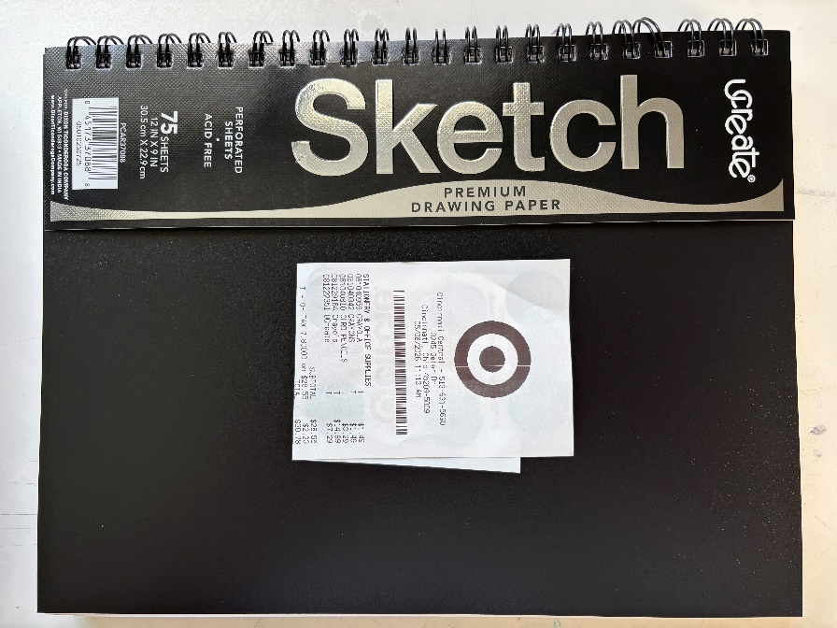
For our purposes, I like the paper in this sketch book. The 9” x 12” sheets will be plenty big for our projects. And the weight and finish of the paper also fit our projects. The weight is not specified.

To see what MS Copilot says about paper weight and acidity, go to last page.

The supplies listed should be enough to get you through all 8 class sessions.

You can spend a fortune on art materials, but you do not need to.

PLEASE FEEL FREE TO USE ART SUPPLIES YOU ALREADY HAVE!

Know your materials:

Try this:

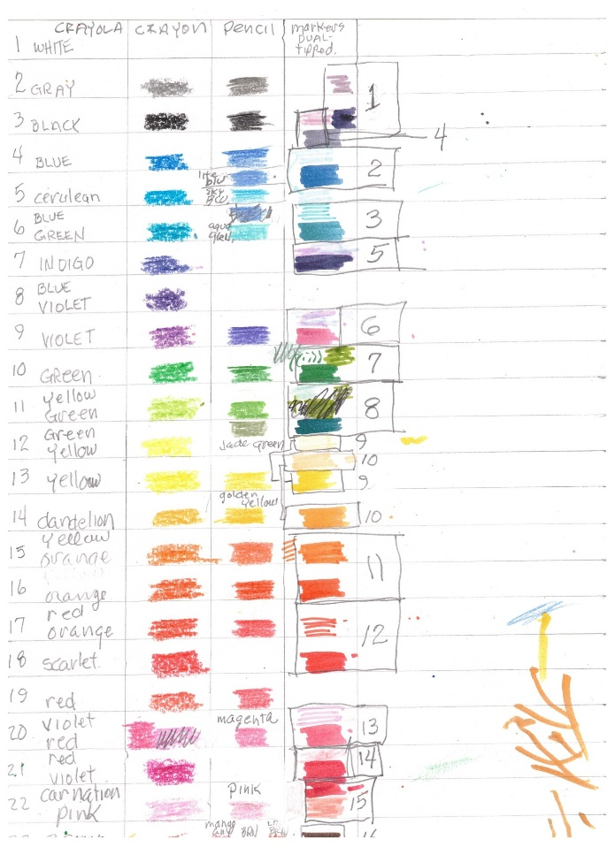
It is nice to know what your crayon/pencil/marker is going to look like on your paper before you apply it! I made this chart for just that purpose.

It is also good to know what color in pencil is like a given color in crayon, etc.

Use a piece of scrap paper to figure out how you like to arrange your colors and what is like what. Then put a chart like this together.

This (like everything I suggest) is optional, but I find it very helpful.

Your natural Ways to Draw:

Try this:

Use your natural body mechanics to find your natural ways to draw. 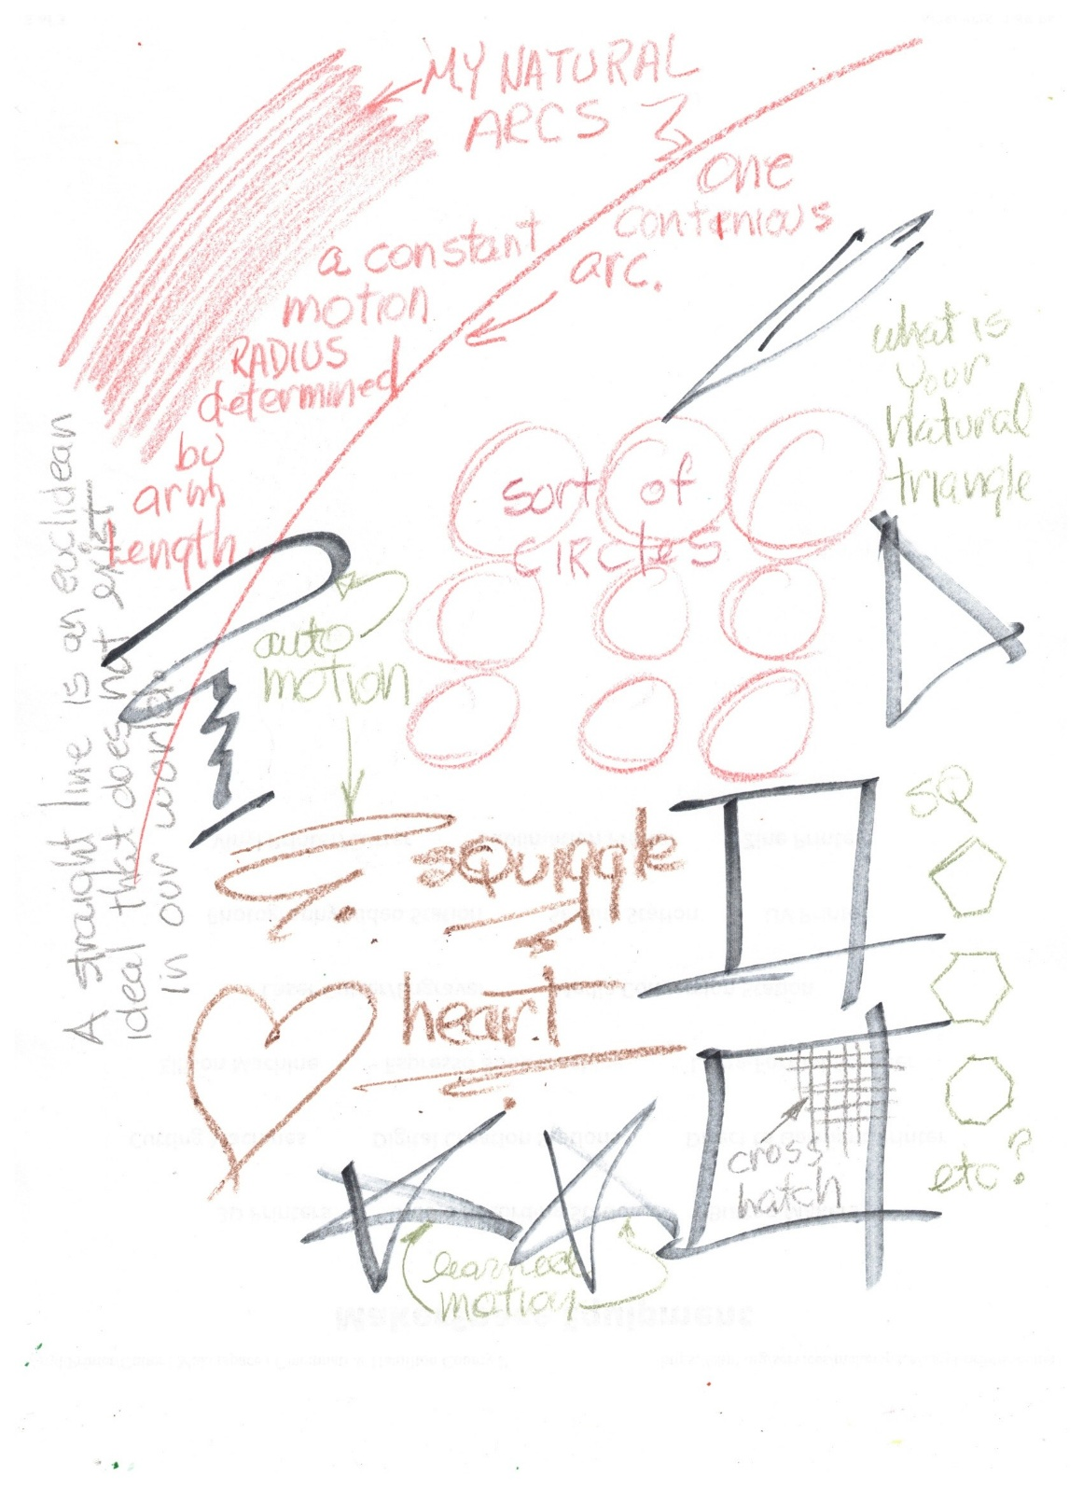
PLAY!
Scribble, doodle.

Try slow, try quick.

Intersect shapes.

Turn the paper.

Look at something and draw without looking at your paper.

Play with quick printing, BLOCK, lower case, cursive.

Vary your pressure.

Draw as your body mechanics both limit and allow.

FYI - Paper: Weight, Acidity, Archival:
Paper weight tells you how thick, dense, and durable an art paper is, and it directly affects how the sheet behaves with wet or dry media. The two systems you’ll see—gsm and lb—look similar but mean very different things.

🎯 Core idea
GSM (grams per square meter) is the only measurement that lets you compare papers across brands and types.
Pound (lb) weight is based on the weight of 500 sheets of a specific “base size,” which changes depending on the paper category.
Jackson's Art Supplies Strathmore Artist Papers

📏 Two measurement systems

1. GSM (g/m²) — the universal, reliable system
- Measures the mass of 1 square meter of paper.
- A 300 gsm sheet weighs 300 grams per square meter, no matter the paper type.
- Lets you compare watercolor vs. drawing vs. printmaking paper directly.
Jackson's Art Supplies

2. Pounds (lb) — the confusing U.S. system
- Measures the weight of 500 sheets (a ream) at that paper type’s base size.
- Base sizes differ:
  - Watercolor: 22" × 30"
  - Drawing: 24" × 36"
- So 80 lb drawing paper ≠ 80 lb watercolor paper—they’re physically different thicknesses.
Strathmore Artist Papers

🧪 Why weight matters for artists
Paper weight affects:
- Buckling / warping under water
- How much scrubbing or layering the sheet can take
- Rigidity (board-like vs. flexible)
- Whether you need to stretch watercolor paper
bestwatercolorpaper.com

📚 Typical art-paper weight ranges

Lightweight (30–90 gsm)
- Very thin, flexible
- Used in printmaking, especially hand-burnished relief prints
- Example: Awagami Kitakata washi at 36 gsm
Jackson's Art Supplies

Medium weight (100–200 gsm)
- Common for drawing, sketching, life drawing
- Easy to roll or transport
- Handles dry media well; limited wet-media tolerance
Jackson's Art Supplies

Standard watercolor weight (300 gsm / 140 lb)
- The most popular watercolor weight
- Good balance of cost and performance
- Will buckle with heavy washes unless taped or stretched
bestwatercolorpaper.com

Heavy watercolor (425 gsm / 200 lb)
- Stiffer, resists warping better
- Often doesn’t need stretching
Jackson's Art Supplies

Extra heavy (640 gsm / 300 lb and above)
- Extremely rigid—behaves like a board
- Can take unlimited water
- 850 gsm+ can substitute for a canvas panel when primed
Jackson's Art Supplies

🔄 Quick conversion reference (approximate)
- 90 lb ≈ 190 gsm — thin
- 140 lb ≈ 300 gsm — standard watercolor
- 200 lb ≈ 425 gsm — heavy
- 300 lb ≈ 640 gsm — extra heavy
bestwatercolorpaper.com

🧭 How to choose the right weight
If you tell me what medium you’re using—watercolor, gouache, ink, graphite, colored pencil, mixed media—I can recommend the ideal weight and surface.

Acid-free Paper:
Acid-free paper matters in art because it directly affects how long your artwork survives without yellowing, becoming brittle, or chemically breaking down. The term sounds simple, but it hides several important distinctions—especially between acid-free, lignin-free, and archival. Here’s the clear, artist-focused breakdown.

🎯 Core takeaway
Acid-free paper has a neutral or slightly alkaline pH (7+), which slows deterioration—but it may still contain lignin unless the manufacturer removes it.
For true long-term stability, you want acid-free and lignin-free, ideally 100% cotton.
Jackson's Art Supplies

🧪 What “acid-free” actually means
A paper is labeled acid-free when:
- It has a neutral or alkaline pH when tested in water (pH 7 or slightly higher).
- It often includes a buffer (usually calcium carbonate) to neutralize acids that may form later.
Jackson's Art Supplies
However, acid-free does not guarantee lignin-free. Some papers are called acid-free simply because no acids were used during manufacturing, even if lignin remains in the pulp.
Jackson's Art Supplies

🌲 Why lignin matters
Lignin is a natural component of wood pulp. When it breaks down, it becomes acidic and causes:
- Yellowing
- Brittleness
- Surface degradation
- Color shifts in artwork
Even if a paper starts acid-free, lignin can make it acidic over time.
info.gaylord.com
This is why newsprint yellows so quickly—it’s full of lignin.
Jackson's Art Supplies

🏛️ What “archival” means (and why it’s different)
“Archival” is often used loosely, but in professional contexts it means:
- Acid-free
- Lignin-free
- Often 100% cotton or purified alpha-cellulose
- No optical brighteners (OBAs), which fade over time
Jackson's Art Supplies artbookprinting.com
Archival papers are engineered to last centuries, not decades.
artbookprinting.com

📏 The gold standard: ISO 9706
If you want the most reliable longevity indicator, look for ISO 9706 certification. It requires:
- pH 7.5–10 (alkaline)
- An alkaline reserve (buffer)
- Very low lignin content (Kappa number < 5)
- High physical strength
artbookprinting.com
This is the standard used by museums and conservation labs.

🧵 Cotton vs. wood-pulp art papers

100% cotton (rag) papers
- Naturally lignin-free
- Extremely durable
- Resist scrubbing, lifting, and repeated erasing
- Best for watercolor, ink, and archival mixed media
Jackson's Art Supplies

Wood-pulp papers
- Can be acid-free but still contain lignin
- More affordable
- Good for sketching, studies, and short-term work
- Not ideal for long-term display unless labeled archival

🎨 What this means for your art practice

If you want your work to last:
Choose acid-free, lignin-free, 100% cotton papers—especially for watercolor, ink, or any piece intended for sale or exhibition.

If you’re doing studies or practice:
Acid-free wood-pulp papers are fine, but expect some yellowing over years.

If you’re making prints or books:
Use archival or ISO 9706 papers to prevent color shifts and brittleness.
artbookprinting.com

